Assignment 2 : Assignments on Operators

Name: Rajesh Mahendra Anerao
Sub: Python for Engineers (PFE)
Roll No.: 15
Branch: CSE-Data Science Engineering

Q 1.
- Problem Statement: Program to find maximum of three numbers
Code:
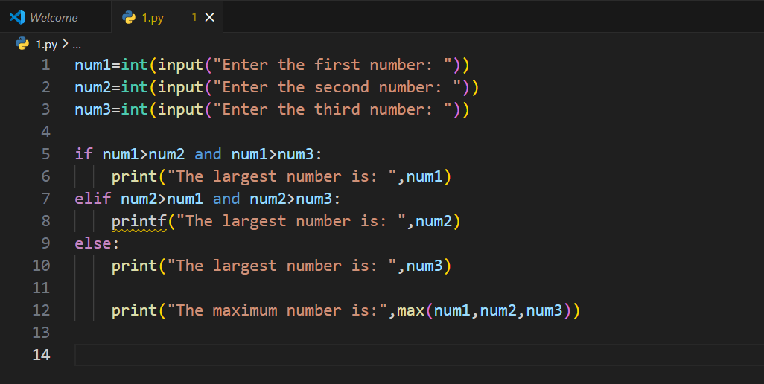
Output:
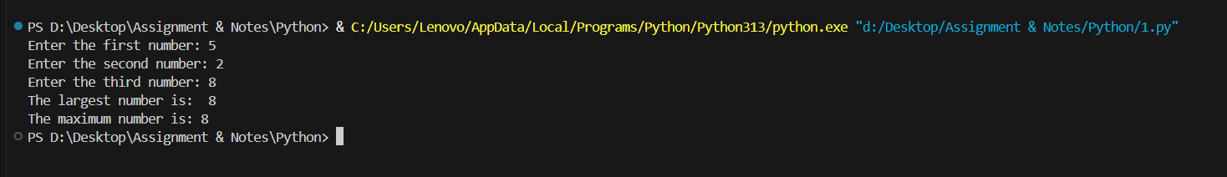
Conclusion:
Thus by taking input from user of three numbers and using conditional statement if, elif , else we get maximum of three numbers

Q 2.
Problem Statement: Program to check if a year is leap
Code:
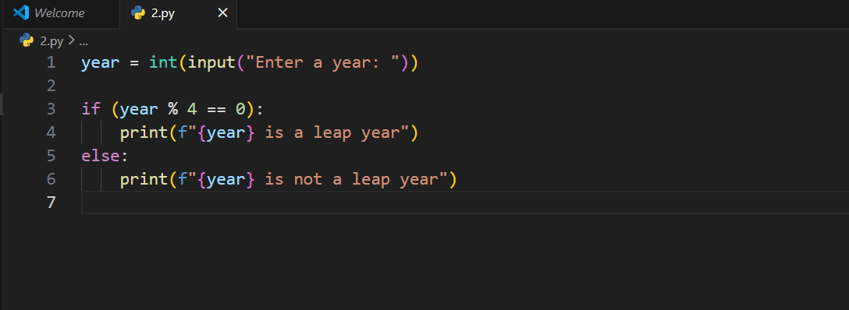
Output:
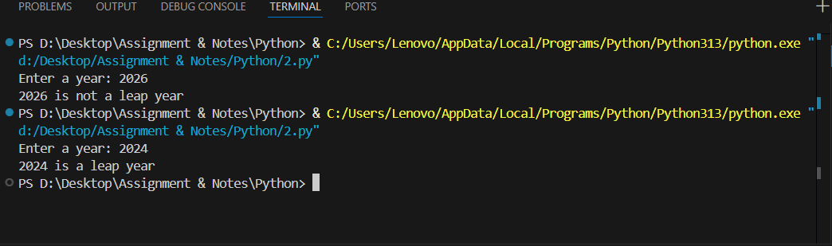
Conclusion:
As leap year come after every 4 years it must be divisible by 4 if not the year is not leap year.

Q 3.
Problem Statement: Program to check if a date is valid
Code:
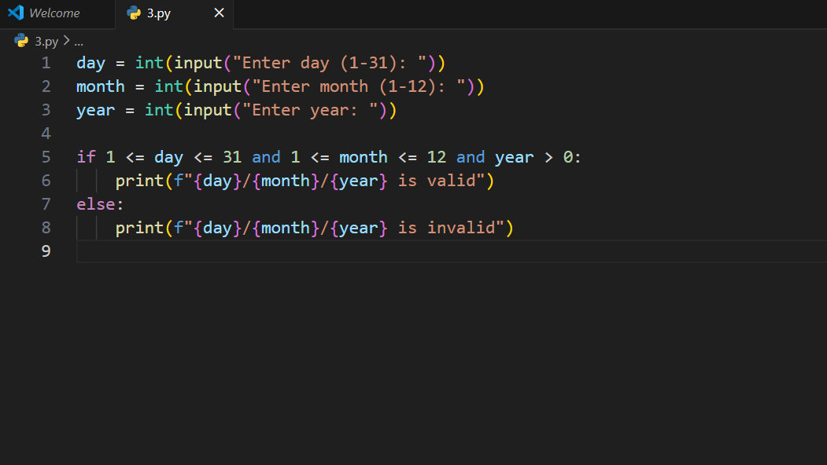
Output:
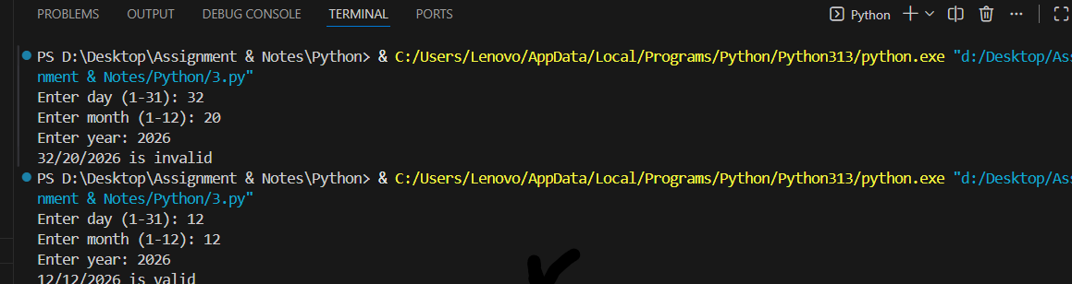
Conclusion:
Taking input day, month, year from user and applying if-else condition we get the output whether the input date is valid or not.

Q 4.
- Problem Statement: Program to find the roots of a quadratic equation
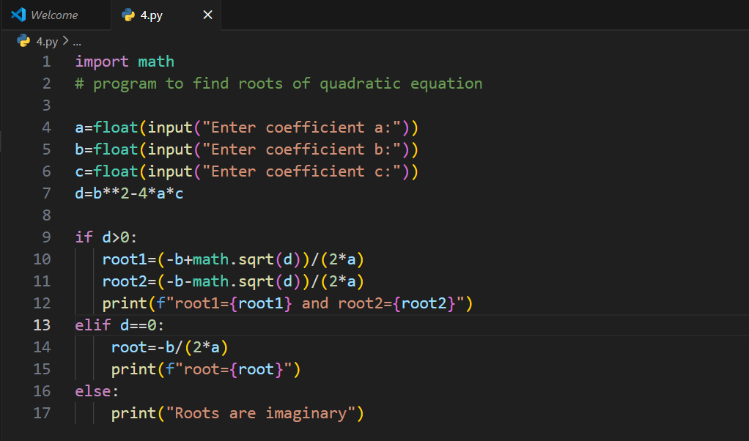
Output:
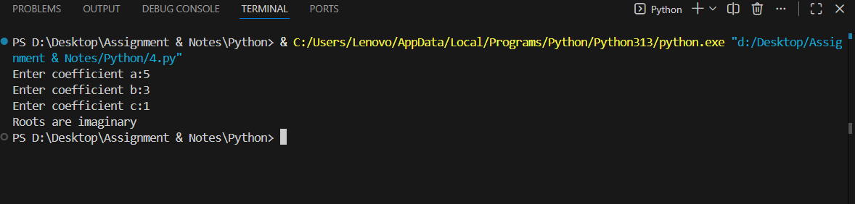
Conclusion:
Taking input of coefficients of a, b, c from user and applying the formula of general solutions of quadratic equations we get the output

Q 5.
- Problem Statement: Given a string. Delete from it all the characters whose indices are divisible by 3.
Code:
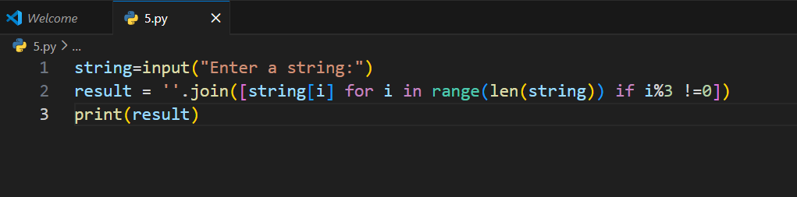
Output:
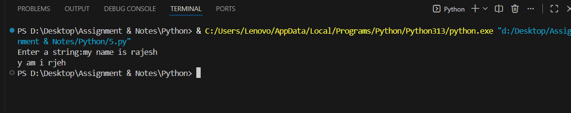
Conclusion:
This program removes characters from a string at indices divisible by 3 (positions 0, 3, 6, 9, ...)

Q 6.
Problem Statement: Given a sequence of integer numbers ending with the number 0. Determine the length of the widest fragment where all the elements are equal to each other.
Code:
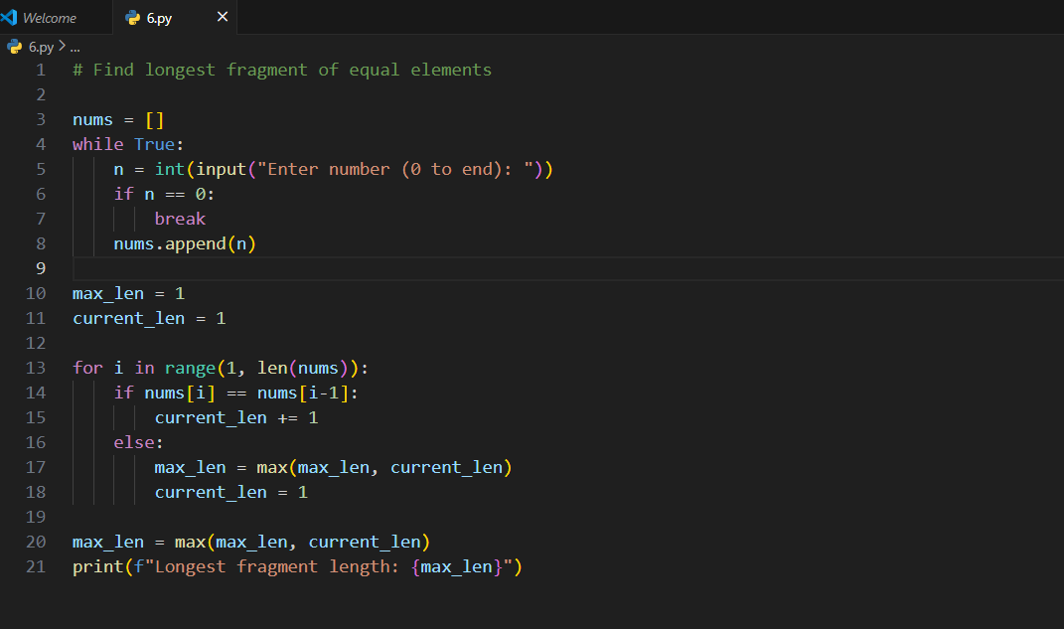
Output:
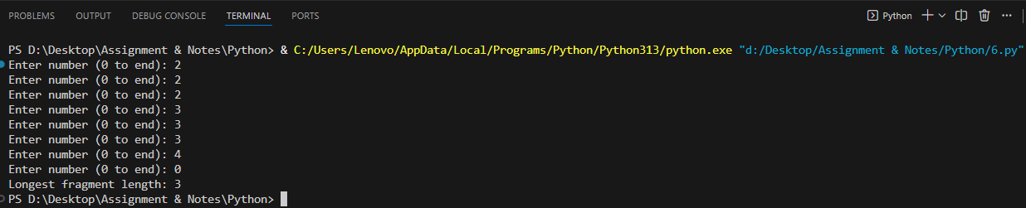
Conclusion:
This program finds the length of the longest consecutive sequence of equal numbers from user input (ends with 0).

Q 7.
Problem Statement: In bowling, the player starts with 10 pins at the far end of a lane. The object is to knock all the pins down. For this exercise, the number of pins and balls will vary. Given the number of pins N and then the number of balls K to be rolled, followed by K pairs of numbers (one for each ball rolled), determine which pins remain standing after all the balls have been rolled. The balls are numbered from 1 to N (inclusive) for this situation. The subsequent number pairs, one for each K represent the start to stop (inclusive) positions of the pins that were knocked down with each role. Print a sequence of N characters, where "I" represents a pin left standing and "." represents a pin knocked down.
Code:
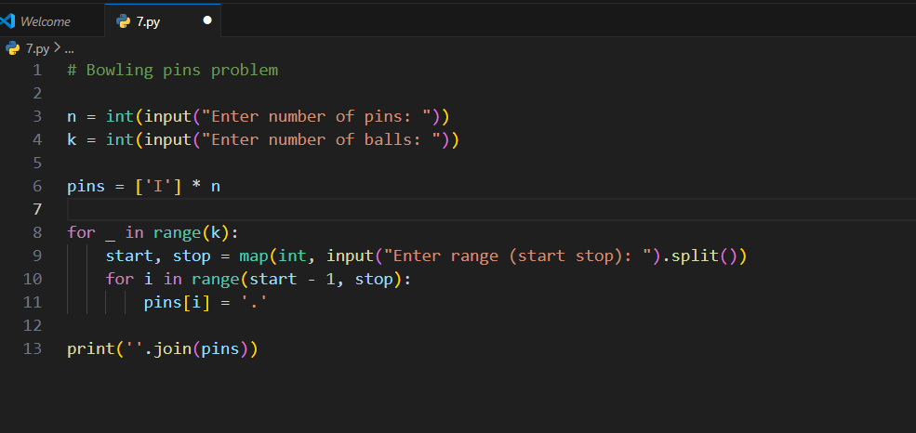
Output:
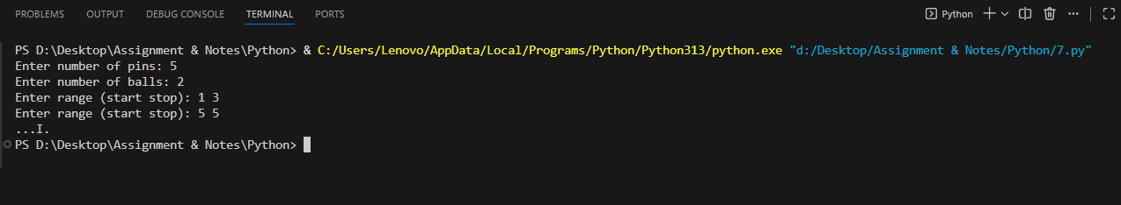
Conclusion:
This program simulates a bowling game, displaying which pins remain standing ('I') and which are knocked down ('.') after all balls are rolled.

Q 8.
Problem Statement: A timestamp is three numbers: a number of hours, minutes and seconds. Given two timestamps, calculate how many seconds are between them. The moment of the first timestamp occurred before the moment of the second timestamp.
Code:
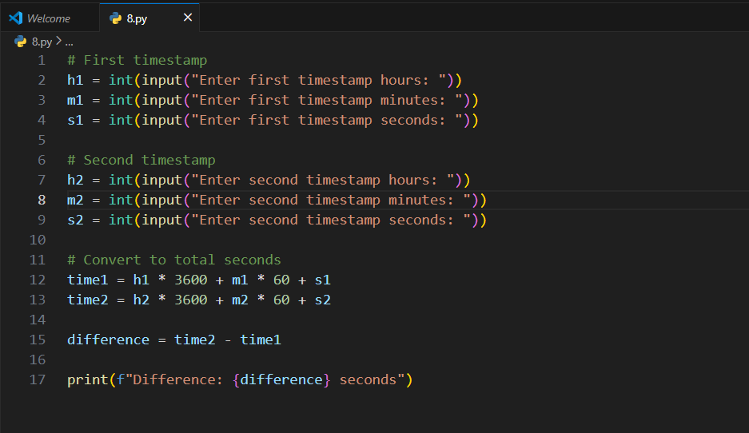
Output:
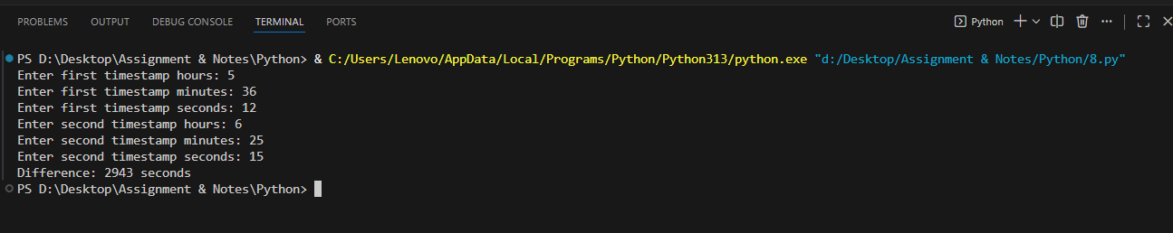
Conclusion:
This program calculates the total number of seconds between two given timestamps.

